Project Development Phase
Model Performance Test

Date | 29 September 2026
Team ID | SWTID-2026-9011
Project Name | Script-Controlled ACL – Restricted Record Access Based on Field Values
Maximum Marks | 10 marks

Model Performance Testing:
Project team shall fill the following information in model performance testing template.
S.No. | Parameter | Values | Screenshot
 | Model Summary | Script-Controlled ACL system in ServiceNow. Access to u_institution_details records is controlled using user roles and Branch field values. ACLs are configured for Read, Create, Write and Delete operations. | 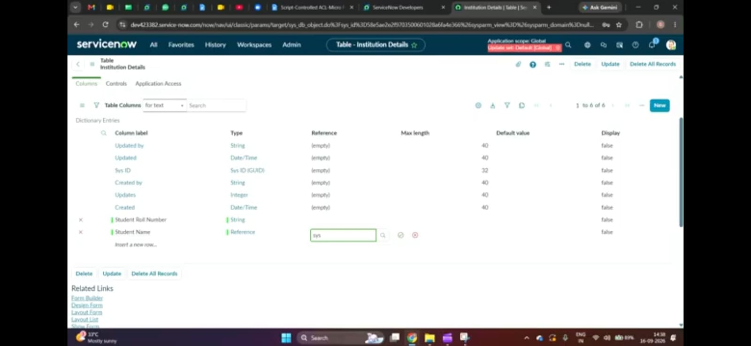
 | Accuracy | Training Accuracy – N/A  Validation Accuracy – N/A  This project does not use a Machine Learning model. Performance is evaluated through functional ACL testing. | 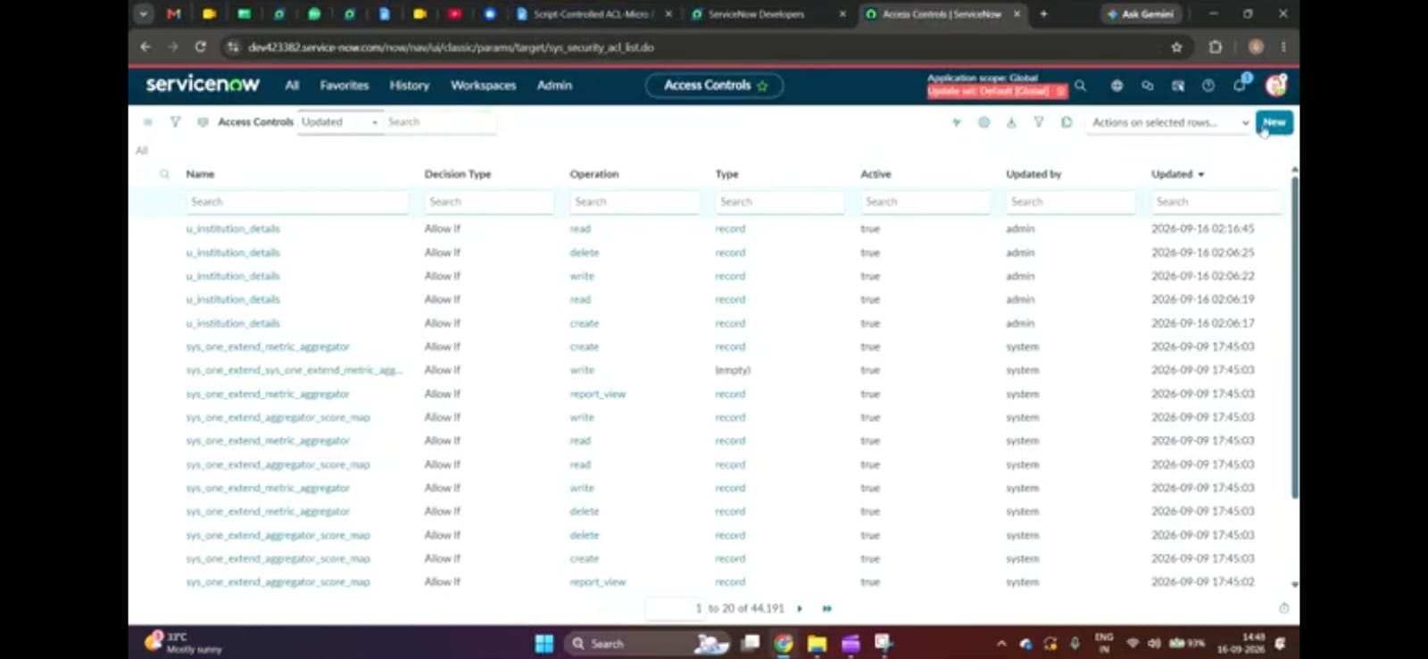
3. | Fine Tunning Result( if Done) | Validation Accuracy – N/A  No ML model fine-tuning was performed. ACL conditions and scripts were configured and tested based on user roles and Branch values. | 